
THE TUBBIES SCHOOL
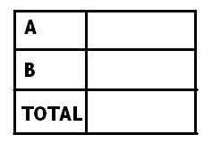END OF TERM II EXAMINATION, 2024
CLASS : P.3

SUBJECT : READING

DURATION : 2 HOURS 15 MINUTES

Name ………………………………………………………………..

1. Listen and write.
a)_____________________
b)______________________
c)_____________________________________________________________
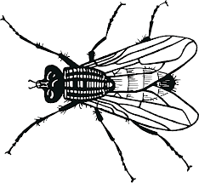
2. Name the given pictures.
a) b) 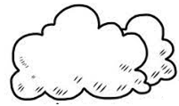

_______________________ ________________________
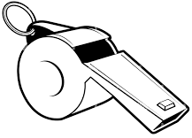
c)

__________________________
3. Write words that end with the following blends.
a) nt___________________ c) ft___________________________
b) sp__________________
4. Use all the letters to make words.
a) bibtra_____________ b) nabd________________
c) keytur ______________
5. Form syllables from the given words.
a) puppy____________ c) logical____________________
b) tender____________ d) pupil_____________________

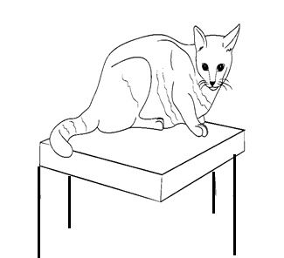
6. Write correct sentences about the pictures.
a)

____________________________________________________________
b)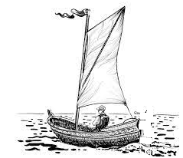
_______________________________________________________________
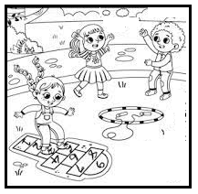
c)

____________________________________________________________
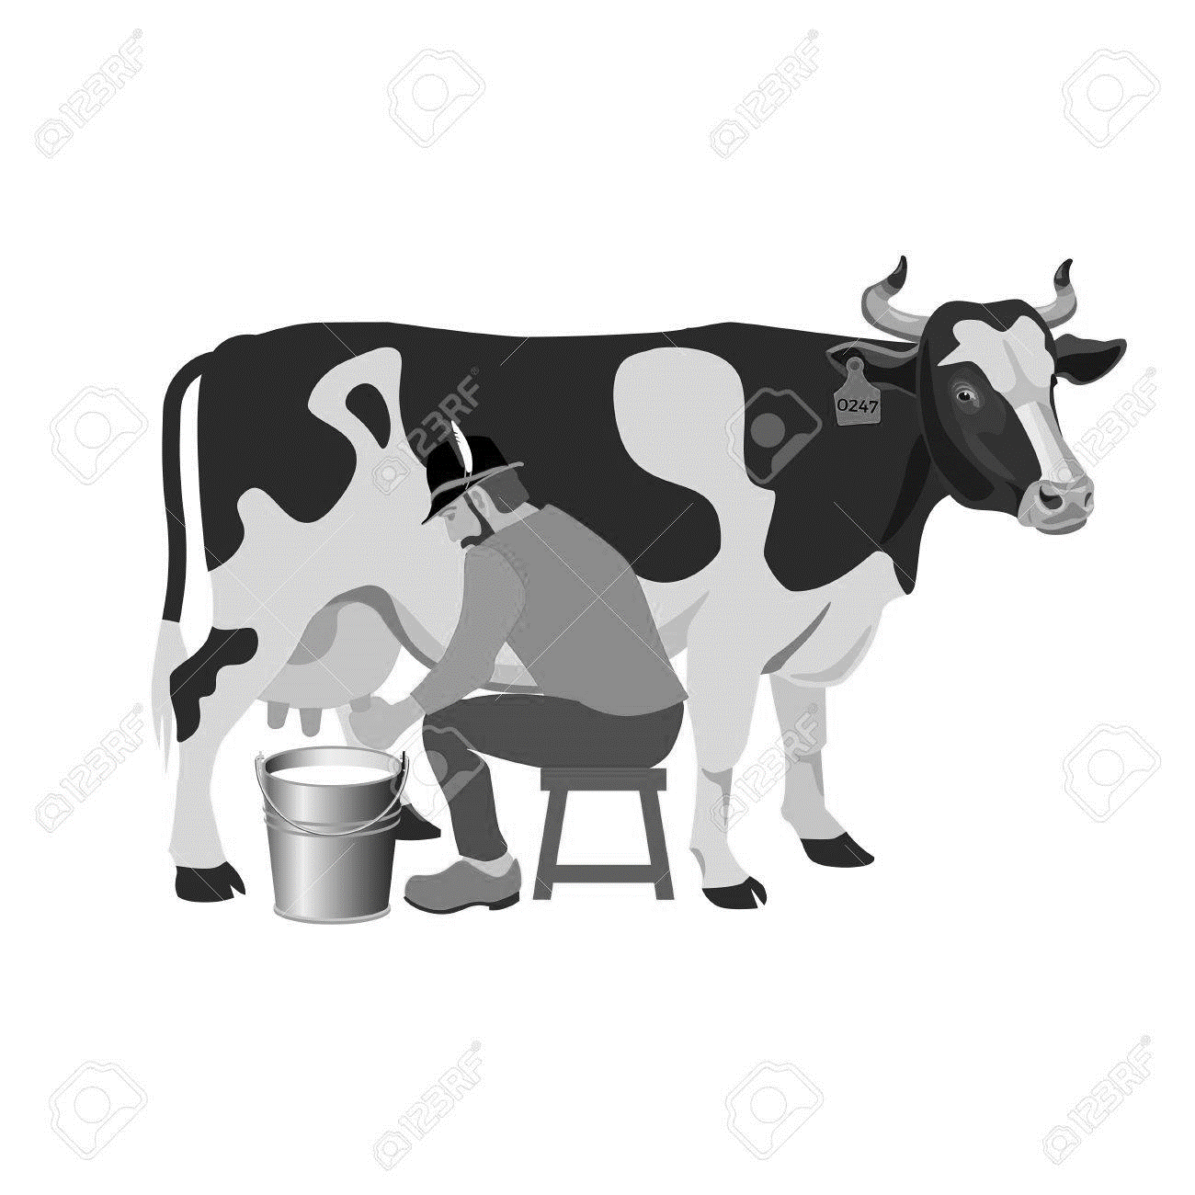
d)

_______________________________________________________________
7. Make words from the given group of letters.
ck | m | p | a
t | ea | fl | ou
sk | cl | d | p

a)________________ b)______________________ c)__________________
d)___________________________ e)__________________
8. Underline the initial blends. Write another word with the blend.
a) blanket_________________ b) stethoscope_____________________
c) smug_________________

9. Complete the given sentences with the most suitable word.
a) Our teacher uses_______________________ to write on the white board.
b) The______________ sang Christmas carols last December.
c) How__________________ sugar is in the bowl?
d) Their baby_____________ for milk last night.

10. Circle and write words with il, le and el.
x | s | t | e | n | c | i | l | f | a
t | h | a | n | k | y | o | u | m | f
c | h | a | p | e | l | b | o | r | u
e | l | e | v | e | n | t | f | h | n
c | o | u | n | c | i | l | r | u | n
l | u | x | u | r | i | o | i | m | e
a | n | k | l | e | l | e | e | b | l
o | u | t | c | o | m | e | n | l | f
u | t | r | i | a | n | g | l | e | y

a) __________________________ b)_____________________________
c) __________________________ d)______________________________
e) __________________________
11. Write the root words for the following.
a) connection___________________ b) official_________________________
b) friendly____________________ d) approval_______________________
12. Write true or false to fill the gaps.
a) A group of singers is a choir._______________________________________
b) We buy things from the market.____________________________________
c) School children work to earn salaries._______________________________
d) Soil erosion leads to fertility of the soil.______________________________
13. Match these words to the statement.
a) nostril body building food.
b) calf mends shoes.
c) cobbler an opening for breathing.
d) meat a young cow.

a) nostril_______________________________________________________
b) calf__________________________________________________________
c) cobbler________________________________________________________
d) meat__________________________________________________________
14. Answer the riddles correctly.
a) I am a mother to twelve children. Their common name is months. Who
am I ?
_______________________________________________________________

b) I am found in your classroom. Teachers use me to straight lines on the
chalkboard. Who am I ?
_______________________________________________________________

15. Use the given words to fill the gaps correctly.
a) That lady has a very______________ daughter.(beauty)
b) Linda is always ___________________ while doing her work.(care)
c) The angry________________ did not go to the city mall.(protest)
d) He gives heavy punishments which makes him_____________.(fear)
e) Mummy bought me a___________________ snack.(break)

16. Complete the crossword puzzle. Use the clues given.
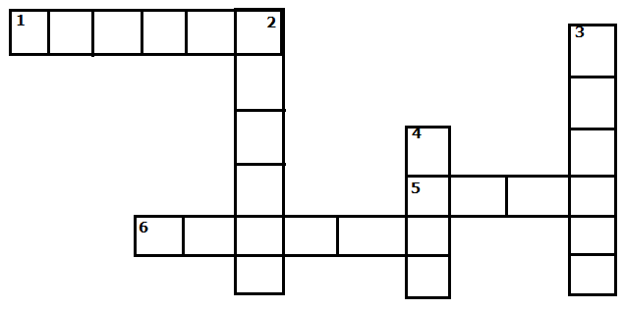
Across.
1. Apart of a plant.
5. plural of egg.
6. young ones of a hen.

Down.
2. an animal with long ears.
3. Used to carry things.
4. A bird lays its eggs.
( eggs, basket, flower, rabbit, chicks, nest)

17. Make words from the word wheel.
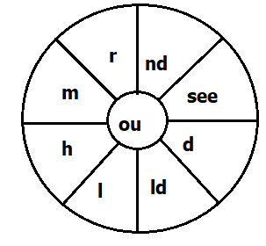
a) __________________________ b)_____________________________
c) __________________________ d)______________________________
e) __________________________
18. Draw pictures for the following.
a) A policeman is running after a thief.

b) My brother’s dog has two puppies.

19. Match and form compound words.
a) bride mission =_____________________
b) match books =_______________________
c) Door box =________________________
d) text way =________________________
e) per groom =______________________

20. Read the poem and answer the questions in full sentences.
LAKE TIME
Sand between my toes.
Only the water knows.
Where the fish go.
For I don’t know.

Boats are dashing.
Children are splashing.
Under a blue sky.
Worries say goodbye.

Sand between my toes.
The whole world knows.
Let it be so.
To the lake we go.
Questions:
a) What is the title of the poem?
_________________________________________________________
b) Where is the sand?
___________________________________________________________

c) According to the poem, what are the boats doing?
___________________________________________________________
d) Which colour is the sky?
__________________________________________________________
e) What knows where the fish go?
_________________________________________________________

